

Benefits Management Tools Team

March 25, 2024| Claim Status Tool 1.0

Revision History

| Date | Version | Description | Author |
| --- | --- | --- | --- |
| 3/25/2024 | 1 | Product Guide First Draft | Jacob Worrell |

Table of Contents

Table of Contents 3

1. Claim Status Tool Overview 4

2. User Access 4

3. Navigation 4

3.1 To application from homepage 4

3.2 Using main menu navigation 6

3.3 Using My VA Dashboard 7

4. Functionality 8

4.1 Viewing list of all claims 8

4.2 Viewing and responding to claim requests 10

4.3 Viewing “Recent Activity” and responding to third-party requests 13

4.4 Uploading files not related to specific requests 14

4.5 Viewing overview “timeline” 15

5. Major Issues and Error Messages 20

5.1 File(s) fails to upload when user attempts to submit evidence 20

5.2 Application fails to load or times out 20

## 1. Claim Status Tool Overview

The Claim Status Tool (CST) is a product on VA.gov that allows veterans and other users to check the status of their claims and appeals. Currently, the most robust status experiences are compensation claim types with disability claims making up the bulk of the traffic. Veterans can view claims related to:

* Disability
* Pensions
* Dependency
* Pre-Need Burial

Dependents/survivors can see information related to a Veteran’s death benefits, such as burials and other claim information when they have survivor of POA status.

In addition, veterans can view information about appeals they’ve filed for compensation claims.

## 2. User Access

Users will need to be logged into the site and be eligible for VA benefits.

## 3. Navigation

**Direct URL: https://va.gov/track-claims/your-claims**

### 3.1 To application from homepage

Users starting from the homepage can first click on Disability.

From the “Disability” landing page, users can scroll down the page to the “Manage your Veterans disability benefits” section then click on the “Check your claim, decision review, or appeal status” link.

Next, the user will be prompted to log in if they are not logged in already. If they are logged in, they will now be in the CST.

### 3.2 Using main menu navigation

Alternatively, the user can use the top menu navigation: VA Benefits and Healthcare > Disability > “Check your claim, decision review, or appeal status”.

### 3.3 Using My VA Dashboard

Users who are already logged in prior to going to CST will default to va.gov/my-va/ as their landing page. From here, they can see snapshots of recent claims. They can choose to click directly into a claim’s details by clicking “Review details”.  
  
To get to the CST landing page, they can click “Manage all claims and appeals”.

## 4. Functionality

### 4.1 Viewing list of all claims

From the first screen of CST, the user will be able to see a list of their claims. The claim “cards” on this page are sorted so that claims with new evidence requests rise to the top of the stack. Otherwise, claims and appeals are sorted in reverse chronological order.  
  
Claim cards show the following info:

* Type of claim
* Whether the claim is “in progress” or “closed”
* When the claim was received
* Which step the claim is in (for compensation claims)
* The last update date for the claim
* Whether an item has an item that needs attention.

For the most common claim type, “compensation”, the next step is usually to click “View details” to review items that need attention.

### 4.2 Viewing and responding to claim requests

The first “detail” view a user will see is the content under the “Status” tab. Above the tab view, the user can view the date this claims was received and the claimed conditions for the claim.

The “Status” content is broken into two primary categories: “What you need to do” and “What we’re doing”.

Content in the “What you need to do” section take the form of individual alerts, often in the form of specific evidence requests. To view more details about a specific evidence request, the user clicks “View Details”.

Once the user clicks “View details”, they will be taken to a request detail page that provides a more detailed description of the request. In addition, the user will have the ability to upload the specific document requested by clicking “Add Files”.

The user can select a file from their device. Once the file is uploaded, they will have to use the drop down and select the file type that most accurately matches the document they uploaded. They will also need to check the box next to the words “The files I uploaded are supporting documents for this claim only”. Once those two steps are complete, the user can click “Submit Files for Review”. If the user clicks “Submit Files for Review” before selecting a document type and/or clicking the checkbox, a validation error will show telling them they can’t submit the files.

### 4.3 Viewing “Recent Activity” and responding to third-party requests

On the “Status tab”, if a user scrolls down the page to the “What we’re doing” section, they will see list of “Recent Activity”. This activity log shows major claim actions taken that includes the time the action was taken and a brief description of those actions. If there is an open third-party request, users will see an alert for it. While they aren’t responsible for meeting this request, if they happen to have the information requested, they can click on “add it here” within the alert.

The user will then be navigated to a request detail page like that described in section 4.2. The instructions for uploading documents are the same.

### 4.4 Uploading files not related to specific requests

At any time while a claim is under review by VA a veteran can upload additional evidence that supports that claim. To do this, they can click the “Files” tab from any claim detail page.

Within the files tab, under “Additional Evidence”, the veteran will be shown the exact same alerts that appear on the “Status” tab described in section 4.2. A veteran should follow the same steps to respond to these requests from this page.

### 4.5 Viewing overview “timeline”

A use can click the “Overview” tab to see a claim phase “timeline”. This sequences the phases of the claim process so veterans know which phase they’re in and where it sits in the overall process. The phase they’re currently in is denoted by a numerical icon.

Another way to see this timeline is from the “Status” tab in the “What we’re doing section”. There they will see a condensed description of the current phase of their claim along with a link “Overview of the process”. Clicking this link will also take them to the “Overview” tab.

If the veteran has additional evidence to submit, not attached to specific requests, they can scroll down the page and click “choose from folder” in the files upload module. Or they can drag files from their device into defined area.

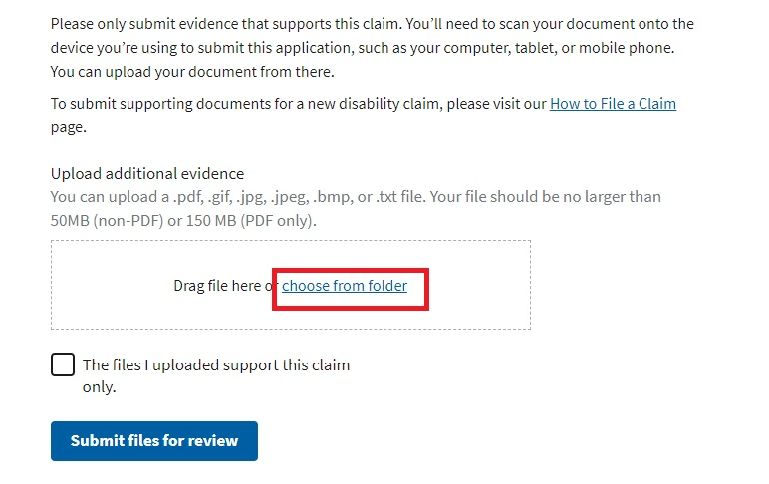

Like the file upload experience described in 4.2, the veteran will have to select a document type and click the checkbox next to “the files I uploaded support this claim only” language. If the veteran neglects to take both or either actions, when they click “Submit files for review”, they will receive validation error messages.

## 5. Major Issues and Error Messages

### 5.1 File(s) fails to upload when user attempts to submit evidence

In the case that a particular piece of evidence fails to upload, instead of the confirmation message, the user will be provided an error alert prompting them that something has gone wrong. This can occur due to one of the downstream services that provides the information being temporarily unavailable or due to application downtime. When this occurs, it is best for the user to wait 1-2 hours and then try again.

### 5.2 Application fails to load or times out

There are also some cases in which the entire application itself fails to load or times out. The user may be presented with an error message saying the application failed or the application may simply never present the content. In both cases, the user will likely try and refresh the page in their browser and sometimes that will resolve the issue. If the application fails to load after repeated attempts at reloading, there could be a service issue affecting all of VA.gov or a service upstream to the application preventing the application to load. In these cases, the user is advised to wait 1-2 hours before trying again.